1 | Name of Project | Introduction of the odour neutralisation system
2 | Term of implementation of the project | 2024-2025 years
3 | Applicant organisation proposing the project | MINSKVODOKANAL UE
4 | Objectives of the Project | 1. Neutralisation of odours from the sewage collector ventilation shafts  2. Development and implementation of the project solution for neutralising unpleasant odours from the sewage collector ventilation shafts
5 | Tasks planned to be performed within the framework of the project implementation | 1. Development and implementation of the project solution for neutralising unpleasant odours from the sewage collector ventilation shafts  2. Neutralisation of unpleasant odours from the sewage collector ventilation shafts
6 | Target groups | Legal entities and individuals of the city of Minsk
7 | Brief description of the measures within the project | 1. Development of the project documentation;  2. Purchase of the odour neutralisation system;  3. Installation, commissioning and start-up of the system;  4. Training of the personnel;  5. Emission monitoring.
8 | Total volume of financing (in US dollars)
 | Source of financing | Total volume of financing (in US dollars)
 | Donor’s funds | - Project documentation: 20 thousand US dollars (approximately);  - Odour neutralisation system: 40 thousand US dollars (approximately);
 | Co-financing | 3% from the cost of the system for training the personnel that is 1,200 US dollars
9 | Project implementation place (region/district, city) | City of Minsk
10 | Contact person: Initials, surname, position, phone, e-mail address | Kudritsky, Alexander Antonovich  (Head of Minskochistvod Enterprise, +375447601064,  KUDRITCKII_AA@minskvodokanal.by)
11 | Justification | Currently, the “Circumferential” gravity sewage collector (with a diameter of 2,000 mm) is in operation of the Enterprise. The collector is provided with 15 ventilation shafts, eleven of which are located within the precincts of the city of Minsk near the Minsk Ring Motorway. During the operation of the collector, unpleasant odours are released into the atmosphere through ventilation shafts, which in turn creates discomfort for residents of nearby houses of the city situated in the area of Kamenogorskaya Street (44 residential buildings housing approximately 7,000 inhabitants) and Slobodskaya Street (66 residential buildings housing approximately 40,000 inhabitants) due to appearance of unpleasant odours. During the survey, it was found that unpleasant odours are released from point sources of the ventilation shafts. As seen above, the facilities of centralised waste water disposal systems, while being operated, are sources of foul-smelling gaseous substances (mainly ammonia, hydrogen sulphide and methane). To solve this problem, gas purification devices based on the use of ozone gas (ozonation) are used.  The effect of ozone on oxidation of the substances, which are formed on the structural elements of the sewage collector and contribute to the destruction of elements as a result of gas corrosion, increases the service life of the structural elements of the collector and reduce the release of unpleasant odours.
12 | Results of implementation of the project | Increasing the comfort of living of the population due to reducing the release of unpleasant odours.
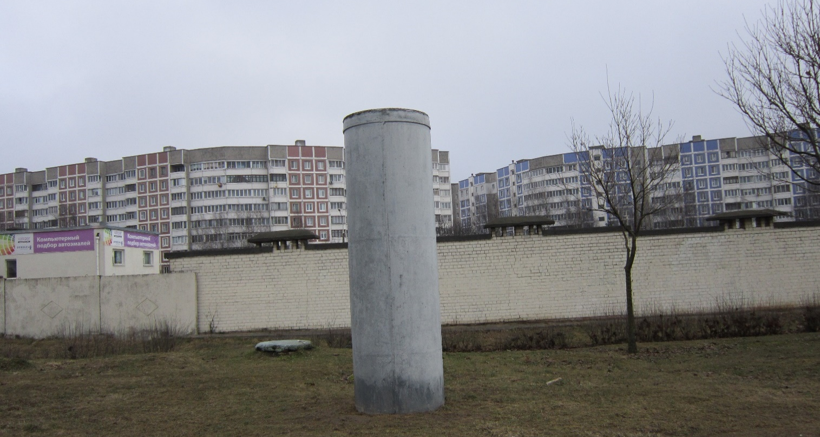

29 Slobodskaya St.

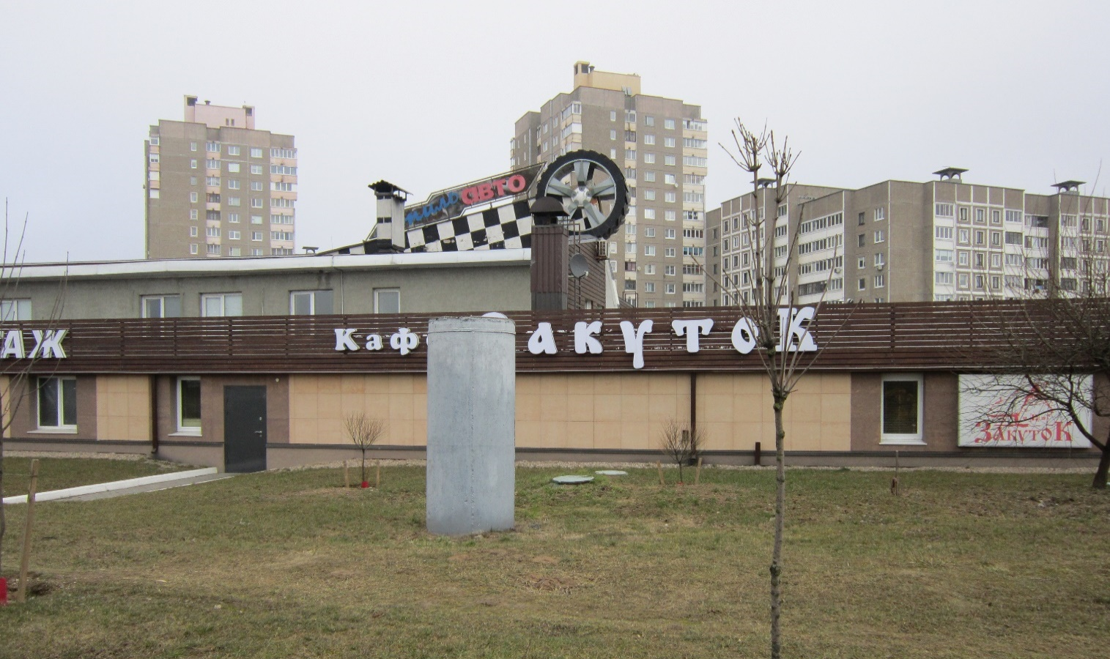

128 Slobodskaya St.

Diagrams of arrangement of exhaust shaft

65 m from the exhaust system to the building
2) Building 7, 19 Briket St.
1) 38 Briket St.
Elevation 0.75 m, D1,100 mm
Elevation 4.6 m, D1,100 mm
38 Briket St.
8) 21-29 Slobodskaya St.
Elevation 4.5 m, D1,100 mm
29 Slobodskaya St.

Elevation 2.7 m, D1,100 mm
9) 91 Slobodskaya St.
128 Slobodskaya St.

10) 117 Slobodskaya St.
Elevation 2.1 m, D1,200 mm
117 Slobodskaya St.

Elevation 3.1 m, D1,100 mm
7) Olshanskaya – Minsk Ring Motorway
Olshanskaya St. – Minsk Ring Motorway

6) Junction of Olshanskaya St. and Minsk Ring Motorway (near the address 90 Shkolnaya St.)
Elevation 0.6 m, D1,200 mm
Junction of Olshanskaya St. and Minsk Ring Motorway (near the address 90 Shkolnaya St.)

Elevation 2.0 m, D1,200 mm
5) 44 Panchenko St.
44 Panchenko St.

4) 21 Panchenko St. (Trolleybus depot)
Elevation 1.6 m, D1,100 mm
21 Panchenko St.

3) Building 2, 37 Briket St.
Elevation 1.5 m, D1,100 mm
Elevation 1.6 m, D1,100 mm
Building 2, 37 Briket St.

